**Onedrive link of assignment:**

[**https://kluniversityin-my.sharepoint.com/:f:/g/personal/2100050046_kluniversity_in/EmEpQ53rs-RGrmgqfYpA1H0Bt3bhv9keo6WMJTzMNJ8cCQ?e=WvmsXM**](https://kluniversityin-my.sharepoint.com/:f:/g/personal/2100050046_kluniversity_in/EmEpQ53rs-RGrmgqfYpA1H0Bt3bhv9keo6WMJTzMNJ8cCQ?e=WvmsXM)

**DAY – 1**

**index.html**

<html lang="en">

<head>

    <meta charset="UTF-8">

    <meta http-equiv="X-UA-Compatible" content="IE=edge">

    <meta name="viewport" content="width=device-width, initial-scale=1.0">

    <title>Color Picker</title>

    <link rel="stylesheet" href="MyStyle.css">

</head>

<body>

    <div class="Demo">

    <div class="Main-Container" id="Main-Container">

        <h1>Color Picker</h1>

        <div class="flex-Container">

        <div class="flex-item">

        <button id="button-1">#e0e0e0</button>

        </div>

        <div class="flex-item">

        <button id="button-2">#6fcf97</button>

        </div>

        <div class="flex-item">

        <button id="button-3">#56ccf2</button>

        </div>

        <div class="flex-item">

        <button id="button-4">#bb6bd9</button>

        </div>

        </div>

        <h2 id="ColorText">Background Color : <span id="SpanText">#e0e0e0</span></h2>

        <p>Try clicking on one of the colors above to change the background color of this page</p>

    </div>

</div>

</body>

<script src="MyScript.js"></script>

</html>

Index.css

body{

    font-family: system-ui, -apple-system, BlinkMacSystemFont, 'Segoe UI', Roboto, Oxygen, Ubuntu, Cantarell, 'Open Sans', 'Helvetica Neue', sans-serif;

}

.Main-Container

{

    border:4px solid black;

    width: 600px;

    height: 600px;

    text-align: center;

    background-color: #e0e0e0;

    margin-left: 340px;

    border-radius: 30px;

    border-width: 10px;

}

.flex-Container

{

    display: flex;

    flex-direction: row;

    flex-wrap: wrap;

    margin-top: 100px;

    margin-bottom: 100px;

    justify-content:space-evenly;

}

#button-1

{

    background-color: #e0e0e0;

    padding: 20px;

    border-radius: 10px;

}

#button-2

{

    background-color: #e6fcf9;

    padding: 20px;

    border-radius: 10px;

}

#button-3

{

    background-color: #56ccf2;

    padding: 20px;

    border-radius: 10px;

}

#button-4

{

    background-color:#bb6bd9;

    padding: 20px;

    border-radius: 10px;

}

#ColorText

{

    font-size:xx-large;

    background-color:#222222 ;

    color: white;

    margin-left: 40px;

    margin-right: 40px;

    border-radius: 30px;

}

button{

    color: black;

    font-size: x-large;

    font-weight: bold;

}

h1{

    font-family: 'Gill Sans', 'Gill Sans MT', Calibri, 'Trebuchet MS', sans-serif;

}

p{

    font-size: larger;

}

#SpanText

{

    color: #49a6e9;

}

**Index.js**

let button1=document.getElementById('button-1');

let button2=document.getElementById('button-2');

let button3=document.getElementById('button-3');

let button4=document.getElementById('button-4');

button1.onclick = function ()

{

    document.getElementById("Main-Container").style.backgroundColor="#e0e0e0";

    document.getElementById("ColorText").textContent="Background Color : #e0e0e0";

}

button2.onclick = function ()

{

    document.getElementById("Main-Container").style.backgroundColor="#6fcf97";

    document.getElementById("ColorText").textContent="Background Color : #6fcf97";

}

button3.onclick = function ()

{

    document.getElementById("Main-Container").style.backgroundColor="#56ccf2";

    document.getElementById("ColorText").textContent="Background Color : #56ccf2";

}

button4.onclick = function ()

{

    document.getElementById("Main-Container").style.backgroundColor="#bbd6b9";

    document.getElementById("ColorText").textContent="Background Color : #bbd6b9";

}

**OUTPUT :**

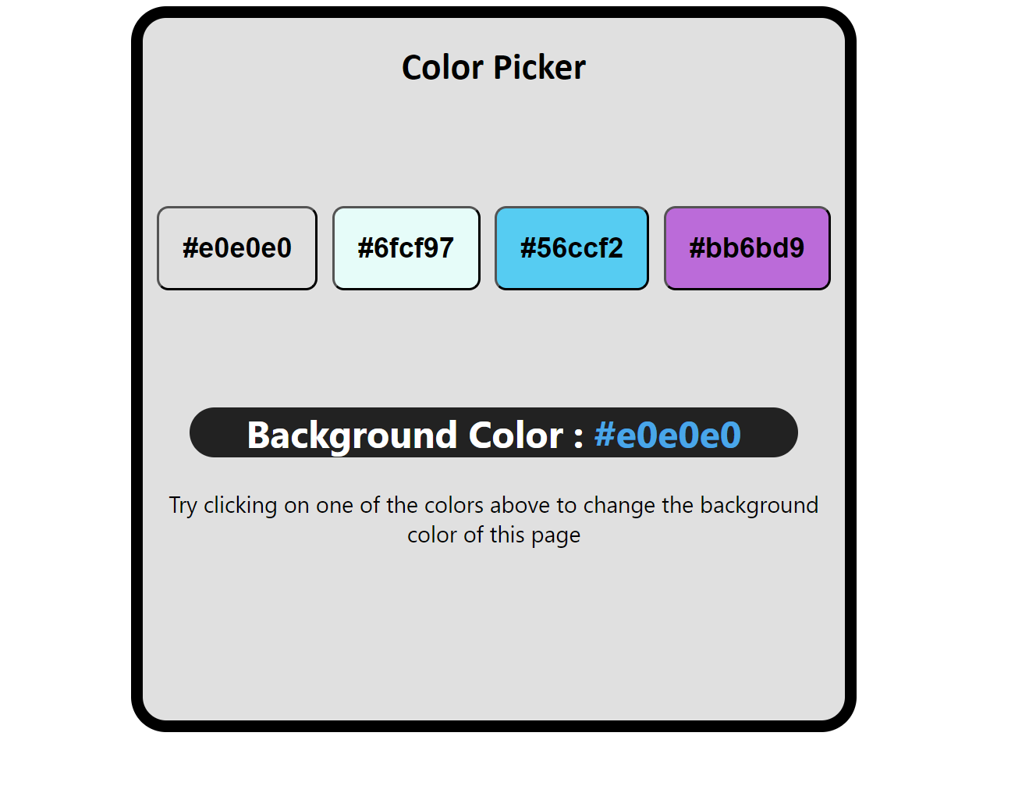

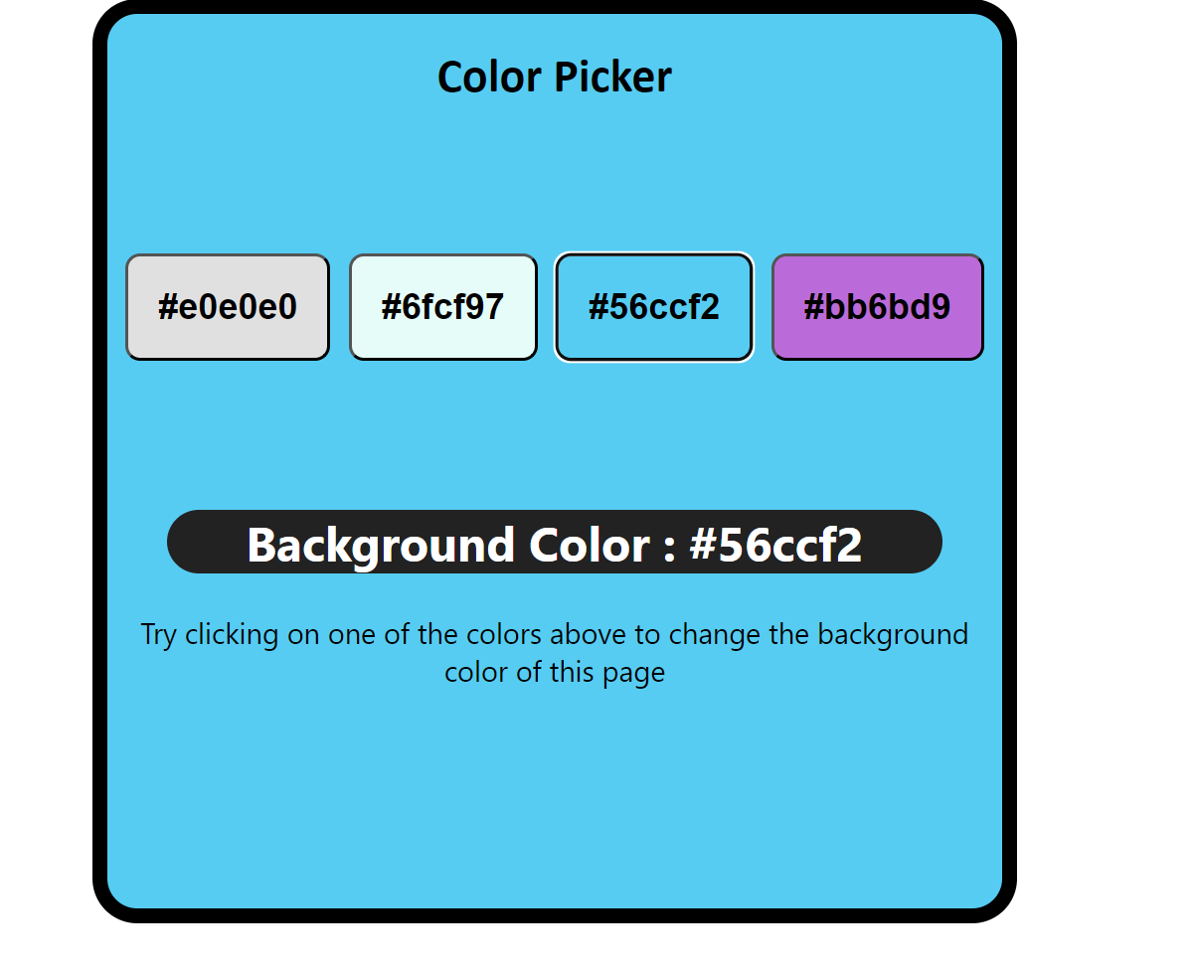

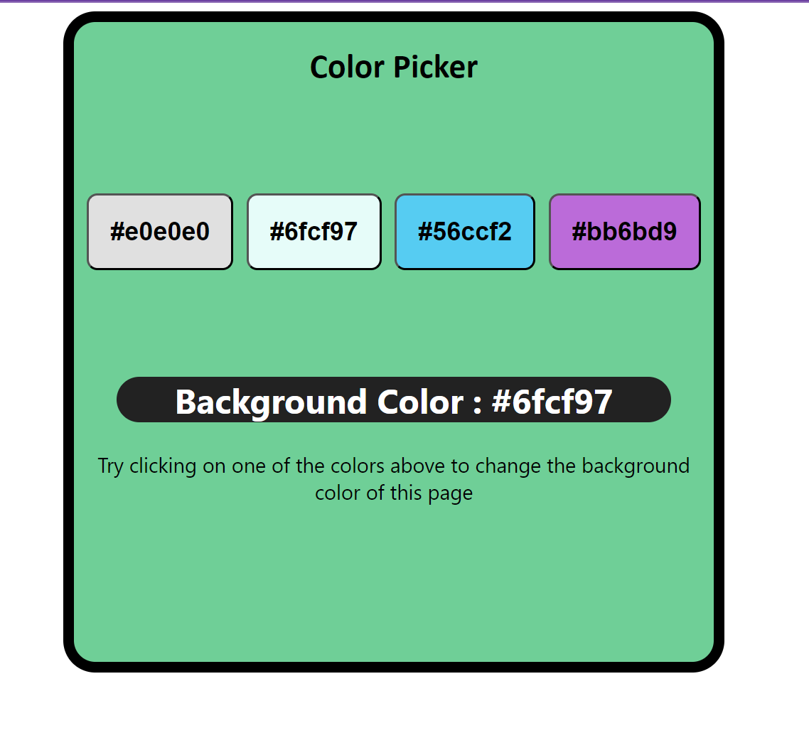

**DAY -2**

**Index.html**

<html lang="en">

<head>

    <meta charset="UTF-8">

    <meta http-equiv="X-UA-Compatible" content="IE=edge">

    <meta name="viewport" content="width=device-width, initial-scale=1.0">

    <title>Task 2</title>

    <link rel="stylesheet" href="MyStyle.css">

</head>

<body>

    <div class="Main-Container">

        <img src="banner.png" id="banner-image" alt="Image not found">

       <h1>

        Tip Calculator

       </h1>

       <label for="BillAmount">BILL AMOUNT</label><br>

       <input type="number" id="BillAmount" placeholder="Enter the value"><br>

       <label for="PercentageTip">PERCENTAGE TIP</label><br>

       <input type="number" id="PercentageTip" placeholder="Enter the value"><br>

       <label for="TipAmount">TIP AMOUNT</label><br>

       <input type="number" id="TipAmount" placeholder="Enter the value"><br>

       <label for="Total">TOTAL</label><br>

       <input type="number" id="Total" placeholder="Enter the value"><br><br>

       <button id="FormButton">CALCULATE</button>

       <div id="NotValid">

       </div>

</div>

</body>

<script src="index.js"></script>

</html>

**Index.css**

.Main-Container

{

  border:2px black solid;

  margin-right: 400px;

  margin-left: 400px;

  height: 500px;

  width: 500px;

  background-color: #f8f9fa;

  text-align: center;

}

#banner-image

{

  width: 100%;

  height: 150px;

}

h1{

  color: #3e4880;

}

button

{

  background-color: #118a8e ;

  color: white;

}

input{

  width: 270px;

}

**Index.js**

let FormButton=document.getElementById("FormButton");

let calculatedTip;

let totalAmount;

FormButton.onclick= function()

{

    let BillAmount= parseInt(document.getElementById("BillAmount").value);

    let PercentageTip= parseInt(document.getElementById("PercentageTip").value);

    if(PercentageTip<=100)

    {

    calculatedTip = (PercentageTip/100)*(BillAmount);

    totalAmount  = BillAmount +calculatedTip;

    document.getElementById("FormButton").style.backgroundColor="blue";

    document.getElementById("TipAmount").value=calculatedTip;

    document.getElementById("Total").value=totalAmount;

    document.getElementById("NotValid").remove();

    }

    else{

        const para = document.createElement("p");

        para.innerHTML = "Please enter the valid input";

        document.getElementById("NotValid").appendChild(para);

    }

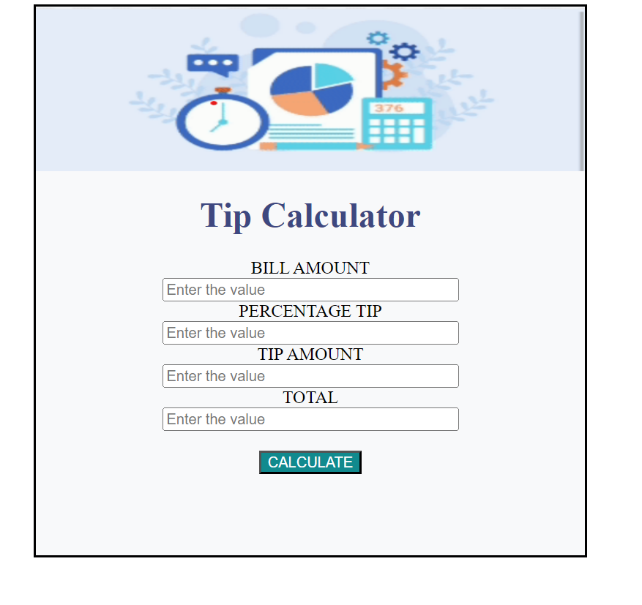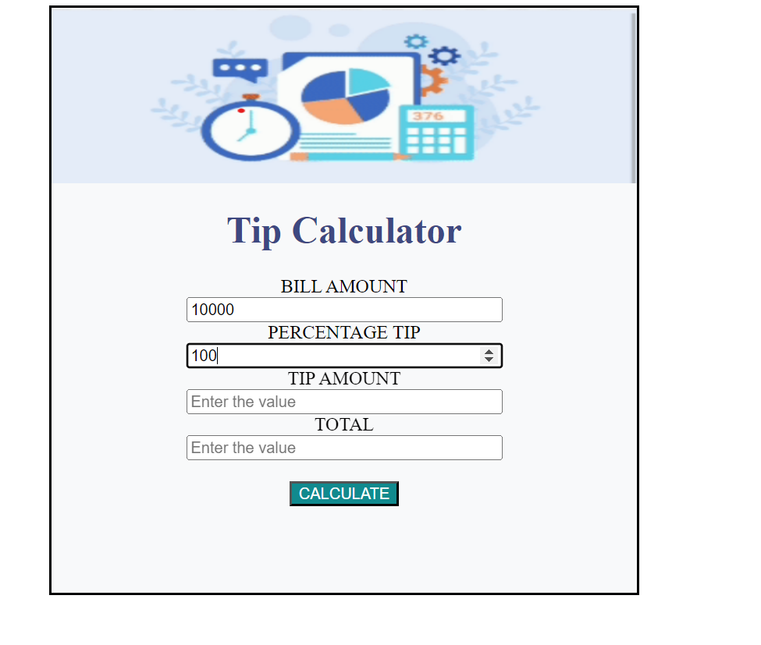

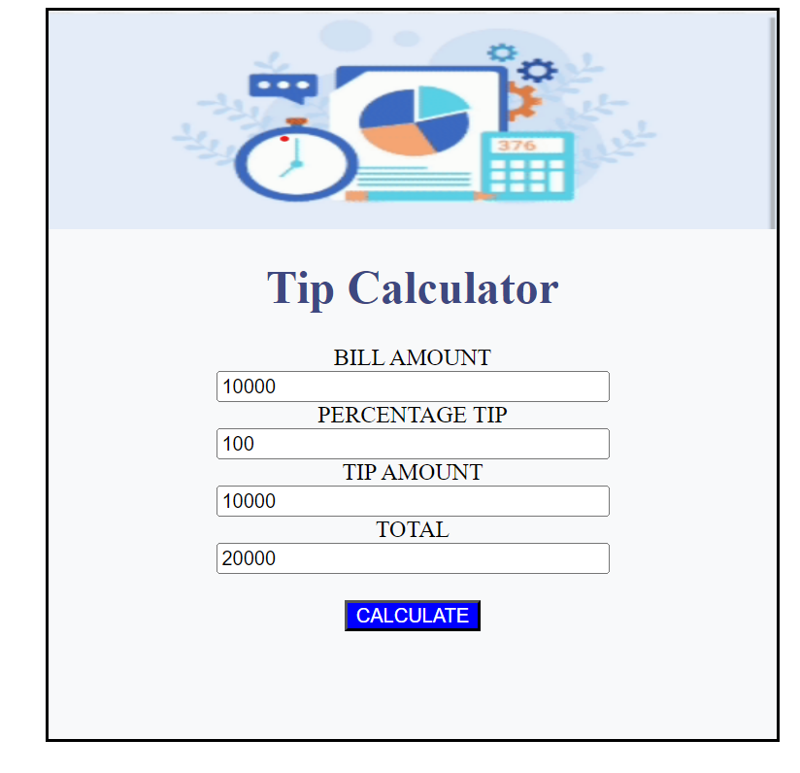

**DAY – 3**

**Index.html**

<html lang="en">

<head>

    <meta charset="UTF-8">

    <meta http-equiv="X-UA-Compatible" content="IE=edge">

    <meta name="viewport" content="width=device-width, initial-scale=1.0">

    <title>Document</title>

    <link rel="stylesheet" href="index.css">

</head>

<body>

    <div class="Main-Container">

        <h1>

            Traffic light

        </h1>

        <div class="Flex-Container">

            <button class="flex-item" id="stop">Stop</button>

            <button class="flex-item" id="ready">Ready</button>

            <button class="flex-item" id="go">Go</button>

        </div>

        <div class="InnerContainer">

               <div class="circle" id="firstlight">

               </div>

               <div class="circle" id="secondlight">

               </div>

               <div class="circle" id="thirdlight">

               </div>

        </div>

        <div>

        </div>

    </div>

    <script src="index.js"></script>

</body>

</html>

**Index.css**

.Main-Container

{

    height: 500px;

    width: 500px;

    border: 2px black solid;

    text-align: center;

    background-color: skyblue;

    margin-left: 300px;

    margin-right: 300px;

    border-radius: 20px;

    margin-top: 100px;

}

button

{

    width: 70px;

    height: 50px;

    font-weight: bold;

    margin-top: 15px;

    border-radius: 10px;

    background-color: #1d1c3f;

    color: white;

}

.Flex-Container

{

    display: flex;

    flex-direction: column;

    float: left;

    margin-left: 130px;

    margin-top: 100px;

}

.InnerContainer

{

    border: 2px black solid;

    height: 300px;

    width: 100px;

    float: right;

    margin-right: 130px;

    margin-top: 50px;

    background-color: #81d1ef;

    border-radius: 40px;

}

.circle

{

    border: 1px black solid;

    height: 70px;

    width: 70px;

    margin-top: 20px;

    margin-left: 15px;

    border-radius: 70px;

    background-color: #494e66;

}

h1{

    font-weight: bolder;

}

**Index.js**

let stop2 =document.getElementById("stop");

let ready=document.getElementById("ready");

let go=document.getElementById("go");

stop2.onclick= function()

{

    document.getElementById("stop").style.backgroundColor="red";

    document.getElementById("ready").style.backgroundColor="#1d1c3f";

    document.getElementById("go").style.backgroundColor="#1d1c3f";

    document.getElementById("firstlight").style.backgroundColor="red";

    document.getElementById("secondlight").style.backgroundColor="#494e66";

    document.getElementById("thirdlight").style.backgroundColor="#494e66";

}

ready.onclick= function()

{

    document.getElementById("stop").style.backgroundColor="#1d1c3f";

    document.getElementById("ready").style.backgroundColor="yellow";

    document.getElementById("go").style.backgroundColor="#1d1c3f";

    document.getElementById("firstlight").style.backgroundColor="#494e66";

    document.getElementById("secondlight").style.backgroundColor="yellow";

    document.getElementById("thirdlight").style.backgroundColor="#494e66";

}

go.onclick= function()

{

    document.getElementById("stop").style.backgroundColor="#1d1c3f";

    document.getElementById("ready").style.backgroundColor="#1d1c3f";

    document.getElementById("go").style.backgroundColor="green";

    document.getElementById("firstlight").style.backgroundColor="#494e66";

    document.getElementById("secondlight").style.backgroundColor="#494e66";

    document.getElementById("thirdlight").style.backgroundColor="green";

}

**OUTPUT:**

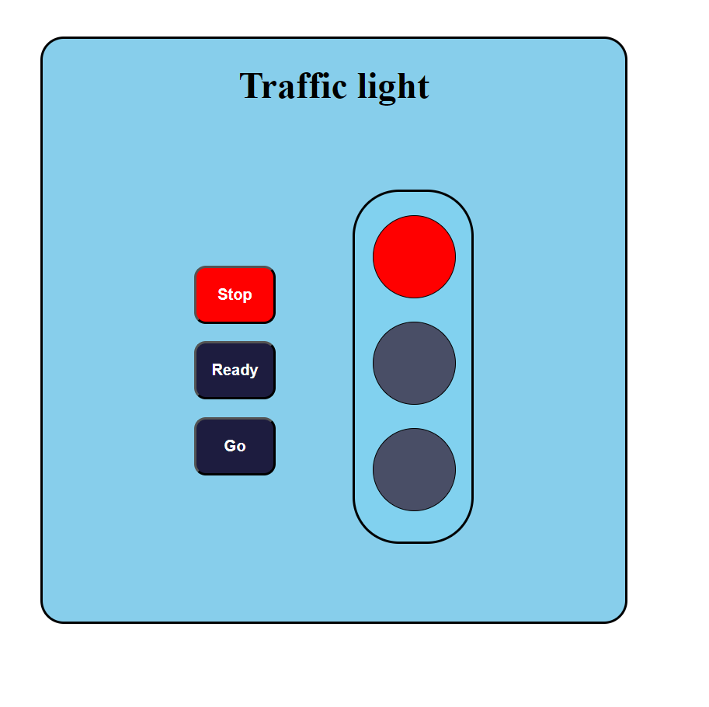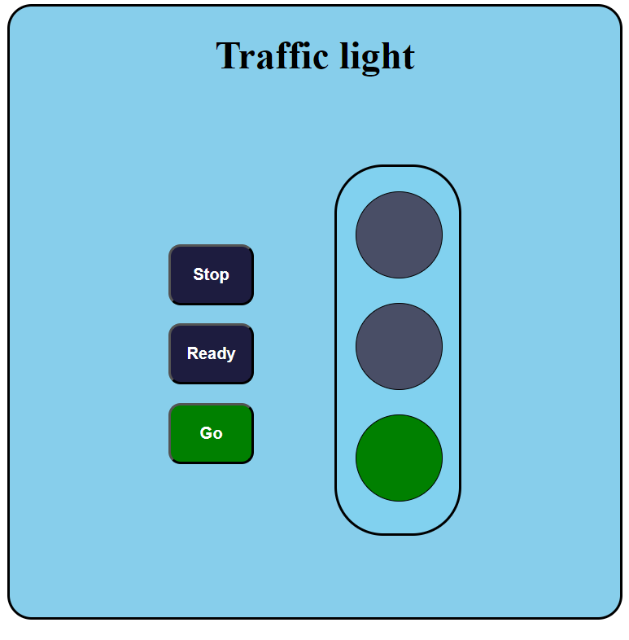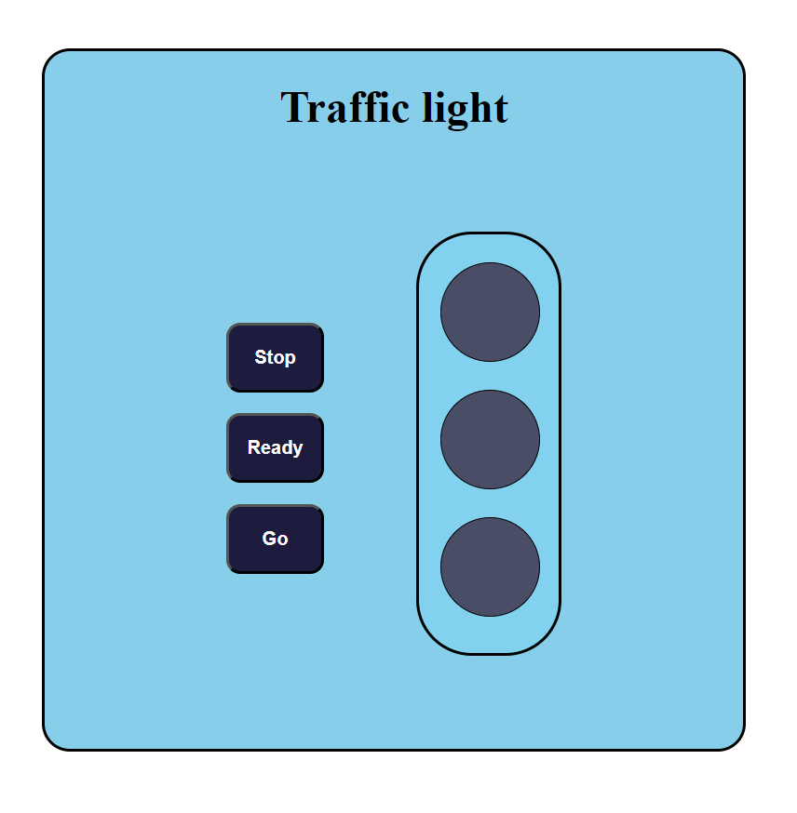

**DAY -4**

**Index.html**

<html lang="en">

<head>

    <meta charset="UTF-8">

    <meta http-equiv="X-UA-Compatible" content="IE=edge">

    <meta name="viewport" content="width=device-width, initial-scale=1.0">

    <title>Task 4</title>

    <link rel="stylesheet" href="index.css">

</head>

<body>

    <div class="Main-Container">

        <input type="textbox" placeholder="Movie name :" id="Movie-Name">

        <br>

        <textarea name="" cols="30" rows="10" placeholder="Movie review :" id="Movie-Review"></textarea>

        <br>

        <button id="sub" style="margin-top: 20px;">Submit</button>

    </div>

    <div id="Append-Class">

        <hr>

        <h3>Given review's :</h3>

    </div>

</body>

<script src="index.js"></script>

</html>

**Index.css**

*

{

    margin: 0;

    padding: 0;

}

.Main-Container

{

    width: 500px;

    height: 300px;

    border: 2px black solid;

    text-align: center;

    margin-left: 50vh;

    margin-right: 30vh;

    margin-top: 5vh;

    margin-bottom: 5vh;

    border-radius: 20px;

}

textarea{

    margin-top: 20px;

    border-radius: 10px;

    text-align: center;

    padding-top: 10px;

}

input

{

    margin-top: 20px;

    text-align: center;

    width: 200px;

}

#sub

{

    width: 100px;

    height: 50px;

    border-radius: 20px;

    border-style: none;

    background-color: violet;

}

#Append-Class

{

    border: 2px black solid;

    width: 100%;

}

**Index.js**

let sub=document.getElementById("sub");

sub.onclick= function()

{

    let linebreak=document.createElement("hr");

    document.getElementById("Append-Class").appendChild(linebreak);

    const MovieName=document.createElement("p");

    MovieName.innerHTML= document.getElementById("Movie-Name").value;

    document.getElementById("Append-Class").appendChild(MovieName);

    const MovieReview= document.createElement("p");

    MovieReview.innerHTML= document.getElementById("Movie-Review").value;

    document.getElementById("Append-Class").appendChild(MovieReview);

    document.getElementById("Append-Class").appendChild(linebreak);

}

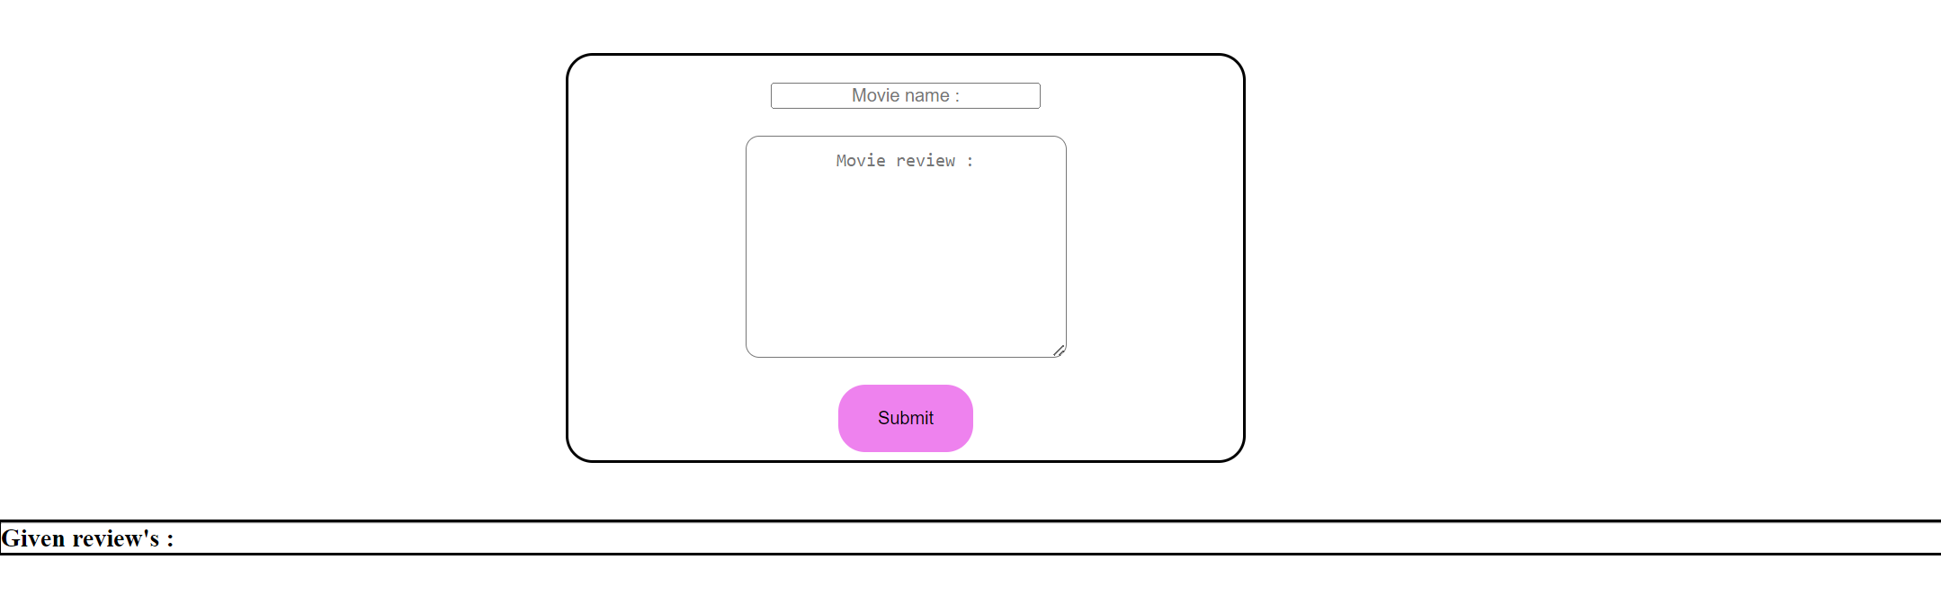

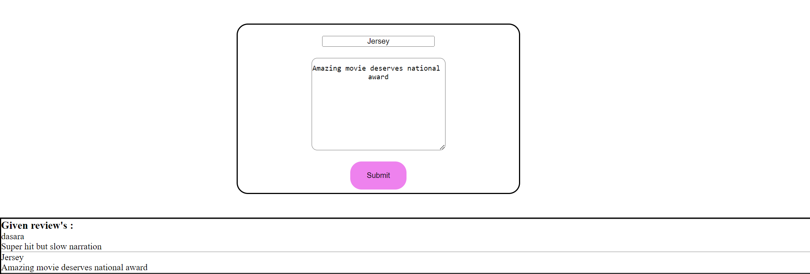

**Day-5**

**Index.html**

<html lang="en">

<head>

    <meta charset="UTF-8">

    <meta http-equiv="X-UA-Compatible" content="IE=edge">

    <meta name="viewport" content="width=device-width, initial-scale=1.0">

    <title>Task 5</title>

    <link rel="stylesheet" href="index.css">

</head>

<body>

    <div class="Main">

             <h1>To Do List</h1>

             <input type="textbox" name="AddTask" id="AddTask" placeholder="Add the task here :">

             <button id="AddButton">Add list</button>

             <h3>Tasks :</h3>

             <div id="ToDoList">

             </div>

    </div>

</body>

<script src="index.js"></script>

</html>

**Index.css**

.Main

{

    height: 500px;

    width: 500px;

    border: 2px black solid;

    text-align: center;

    background-color: lightpink;

    border-radius: 30px;

}

button

{

    width: 70px;

    height: 40px;

    border-radius: 10px;

    border-style: dotted;

    font-weight: bold;

    color: white;

    background-color: violet;

}

h1{

    color: blue;

}

button:hover

{

    color: black;

    transition: all 0.4s ease 0s;

}

#AddTask

{

    width: 250px;

    height: 30px;

    border: 2px black solid;

    margin-right: 20px;

}

#ToDoList

{

  margin-top: 30px;

  font-weight: bold;

  font-size: larger;

  color: blue;

}

#ToDoList button{

    width: 60px;

    height: 20px;

    margin-left: 40px;

}

**Index.js**

let AddButton=document.getElementById("AddButton");

AddButton.onclick= function()

{

    if(document.getElementById("AddTask").value!="")

    {

    let Task=document.createElement("input");

    Task.type="checkbox";

    Task.id="TaskId";

    let Label=document.createElement("label");

    Label.htmlFor="TaskId";

    Label.innerHTML=document.getElementById("AddTask").value;

    document.getElementById("ToDoList").appendChild(Label);

    document.getElementById("ToDoList").appendChild(Task);

    document.getElementById("AddTask").value="";

    let button=document.createElement("button");

    button.innerHTML="DONE";

    document.getElementById("ToDoList").appendChild(button);

    button.onclick= function()

    {

        if(Task.checked)

        {

        Label.style.textDecoration="line-through";

        document.getElementById("ToDoList").removeChild(Task);

        document.getElementById("ToDoList").removeChild(button);

        }

    }

    let linebreak=document.createElement("br");

    document.getElementById("ToDoList").appendChild(linebreak);

    }

    else{

        alert("Enter something");

    }

}

**OUTPUT :**

